Reg. No.

Ph.D COURSEWORK EXAMINATION - SEPT/OCT 2023

CODE: SPH2

SUBJECT: AEROSPACE ENGINEERING
SPECIALIZATION PAPER 2
THIN-WALLED AIRCRAFT STRUCTURES
Time: 03 hours Maximum Marks: 50

Student Name: Venkateswarlu

Instructions:
- Section A Compulsory
- Answer any four from Section B
- Each question carries 10 Marks

SECTION A

Answer the following question: (10 Marks)
  - a) Explain the shear flow distribution in thin walled beam subjected to transverse shear force 5
b. Determine the shear flow in the thin walled closed symmetrical rectangular beam of uniform thickness ‘t’, height’ h’ and breadth’ b’, also draw the shear flow diagram 5

SECTION B
Answer any four from the following question: (Each carrying 10 Marks)
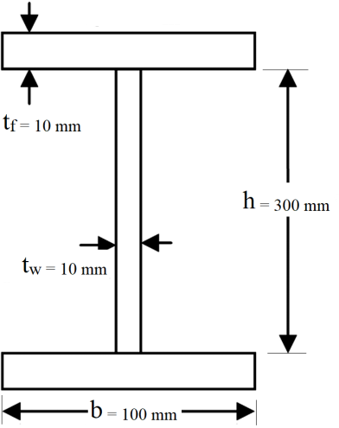
  - Determine the direct shear stress distribution in the flange and web of the ‘I’ section due to transverse shear force of 3 KN. Consider Flange width is 100 mm, height of the web is 300 mm and thickness of the web and flange is 10 mm as shown in fig. 1, Draw the shear stress distribution diagram. 10
fig. 1
  - A cantilever rectangular beam of span L is subjected to an inclined concentrated load P at an angle α to the symmetrical ‘y’ axis as shown in fig. 2(a,b). Determine the bending stress and locate the neutral axis. Also determine the net deflection and total energy stored. 10

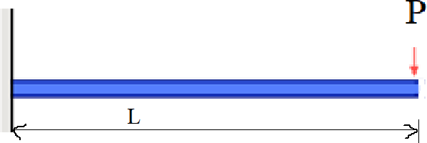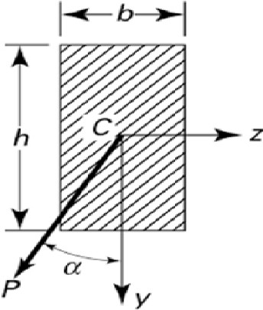
(a) (b)
fig. 2 (a,b)
4. a) What are the various types of riveted joints and explain the modes of failure of joints with neat sketches 5
b. An eccentrically loaded riveted joint is as shown in fig. 3. Design the diameter of the rivet, if the maximum shear stress of the rivet is 120 Mpa and factor of safety is 3. 5

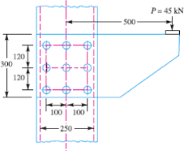
fig. 3

5.a. Explain the concept of structural idealization of wing and fuselage with the help of neat sketeches 5
b. Idealize the box section as shown in fig. 4 into an arrangement of direct stress-carrying booms positioned at the four corners and panels which are assumed to carry only shear stresses. 5

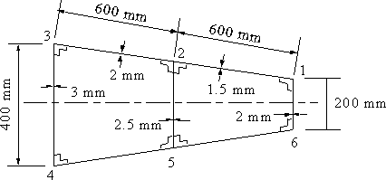
fig. 4

6.a. Derive the Bredth Batho equation due to twisting of thin walled beam closed section subjected to torsion. Also determined the angle of twist and strain energy stored. 5
b. Determine the shear flow and angle of twist for the two cell thin walled closed structure subjected to torsion as shown in fig. 5 5
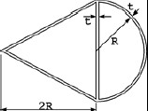
fig. 5
7.a. Derive the Euler bucking equation for slender column hinged at both the ends 5
b. What is the major drawback of Euler buckling theory and how it is modified by Rankine theory
5

********

